Hospital Information System

Aim: To create a cloud-based Hospital Information System for SIMATS Hospital using Zoho Creator to manage patient and doctor information.
Procedure:
- Log in to Zoho Creator and create a new application.
- Create a form named Patient Information.
- Add fields such as Patient Name, Age, Address, Phone, Email, Attender Name, Attender Phone, Doctor Name, and Disease.
- Enter patient information and save the records securely.
- View and manage patient details online with appropriate access permissions.
Implementation
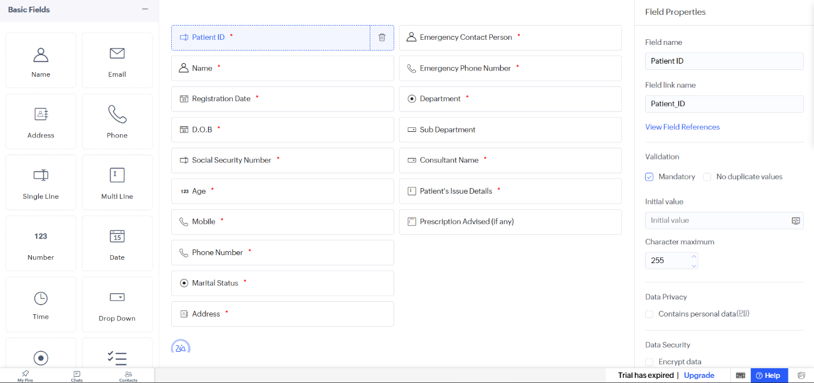

Result: Thus, a cloud-based Hospital Information System was created successfully to maintain patient and hospital information

